1. Create an Instance of Application Insights

* Screenshot showing the creation of an Application Insights instance in the Azure portal.

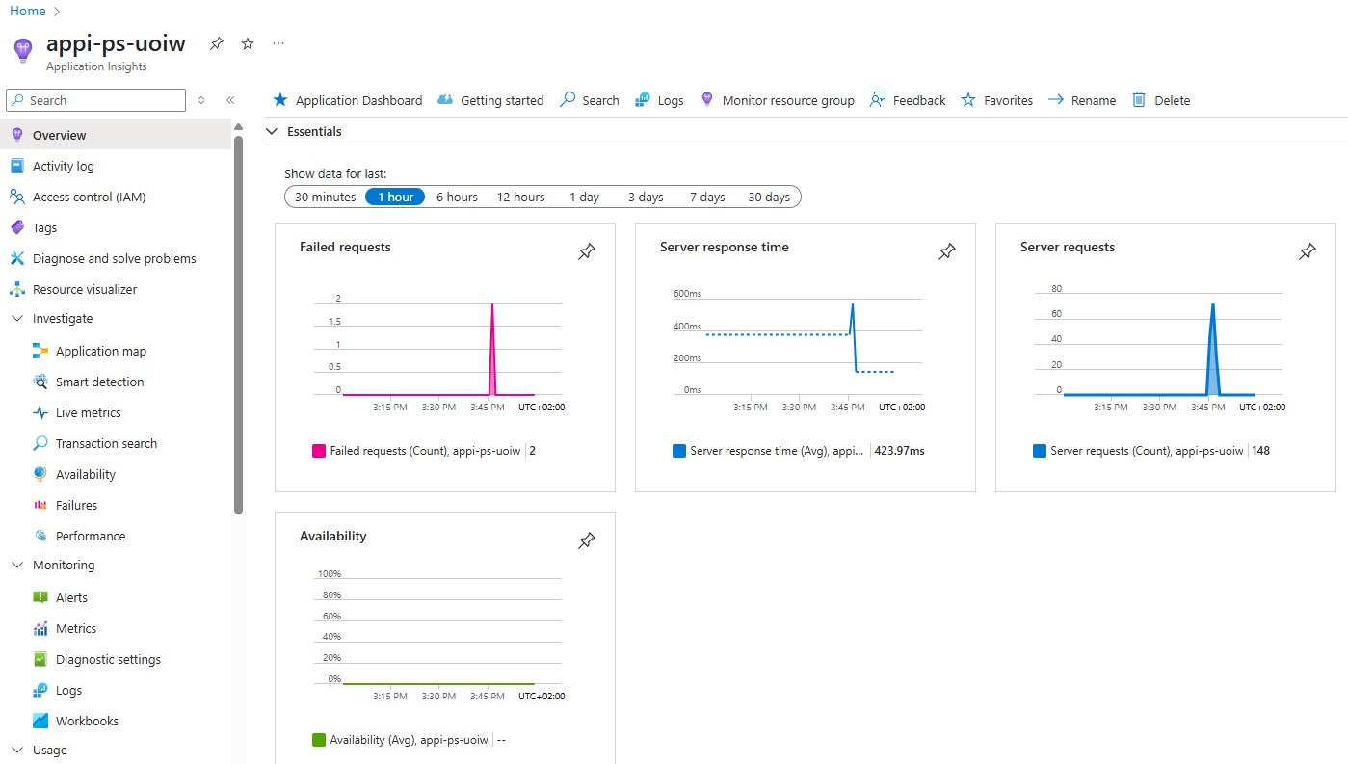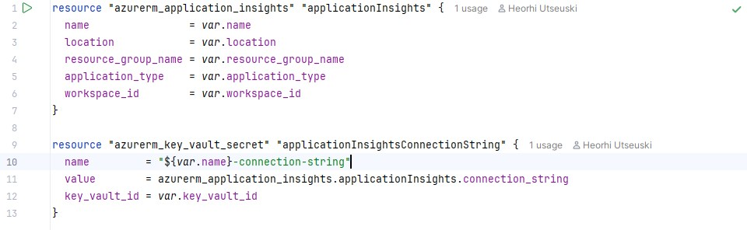

1. Enable Connection to Application Insights

* Screenshot demonstrating integration with Application Insights.

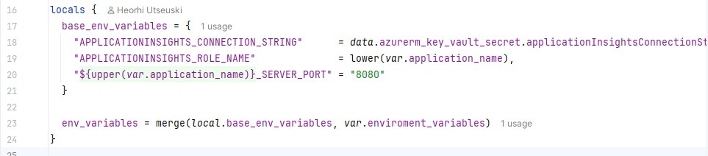

* Screenshots of the deployed PetStore services with enabled Application Insights connections.

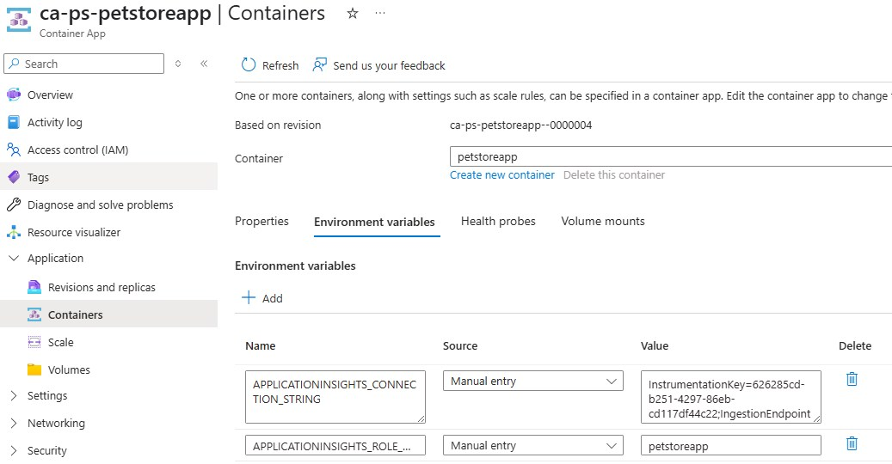

1. Browse the Pet Store Website

* Screenshots capturing the process of adding multiple products to the shopping cart on the Pet Store website.

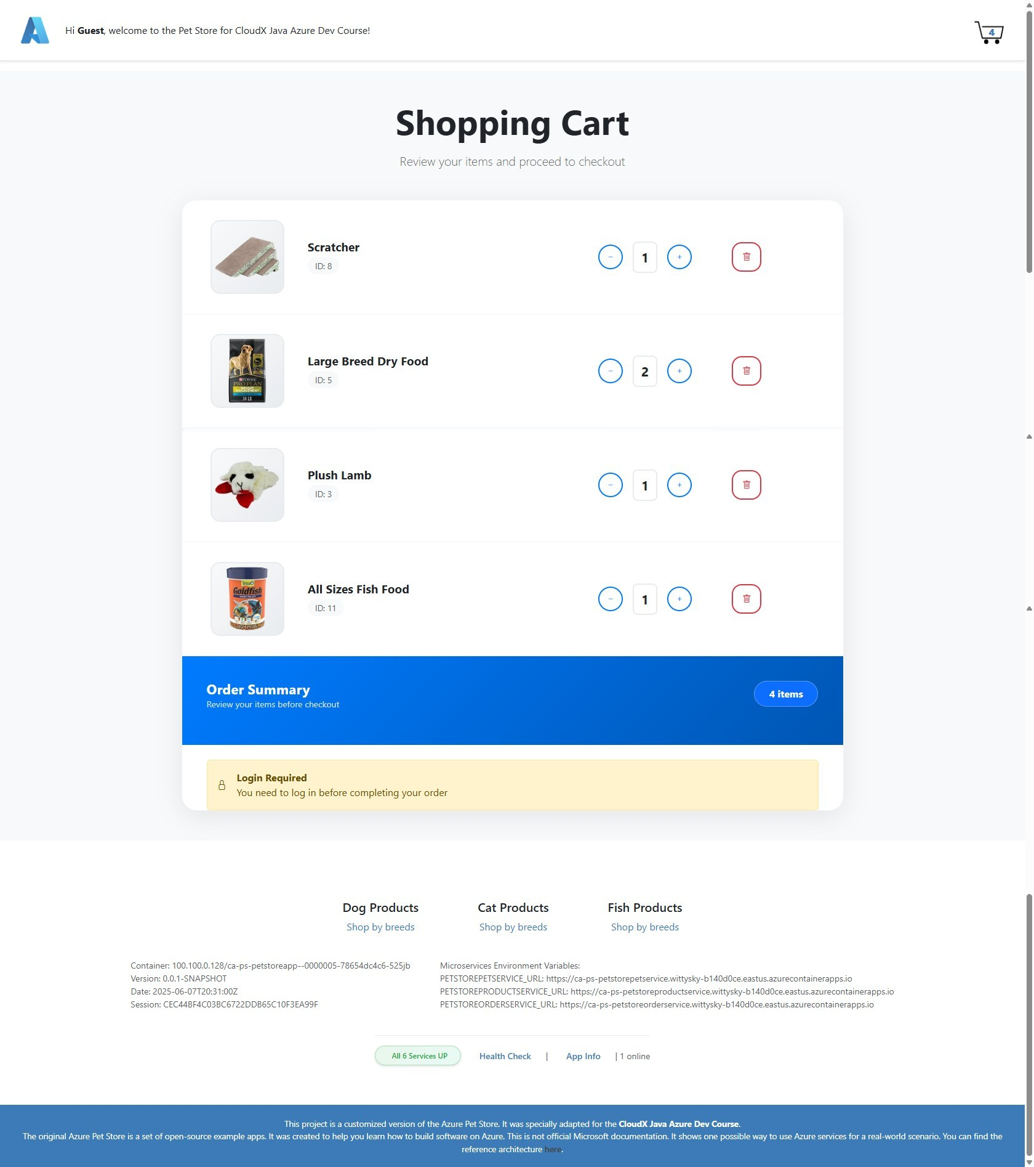

1. Check Application Insights

* Overview tab displaying incoming requests and failures.

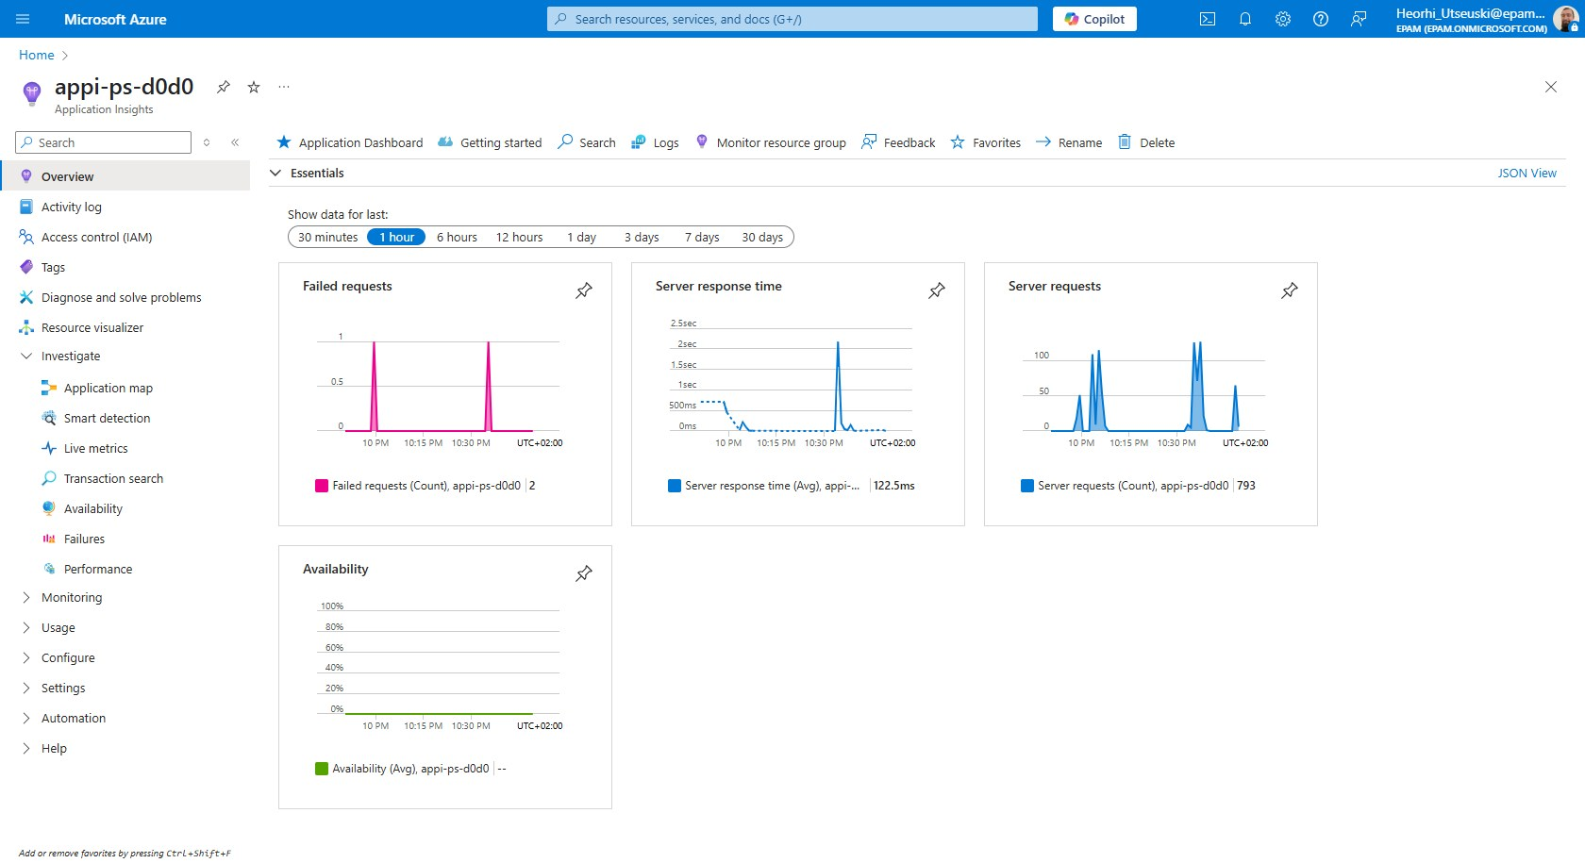

* Live metrics tab displaying real-time metrics.

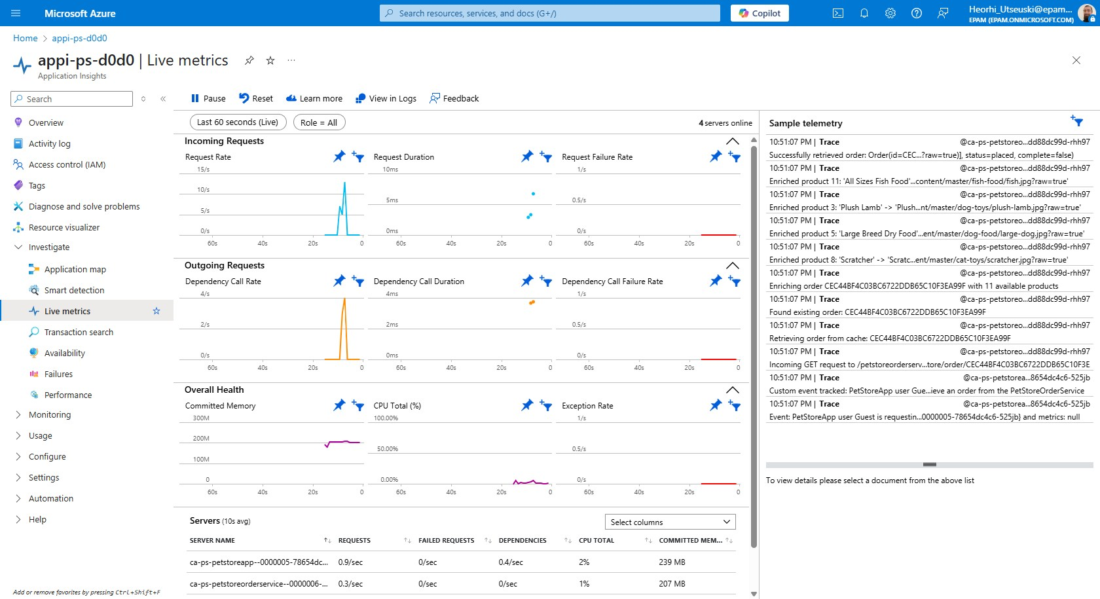

* Transaction search results.

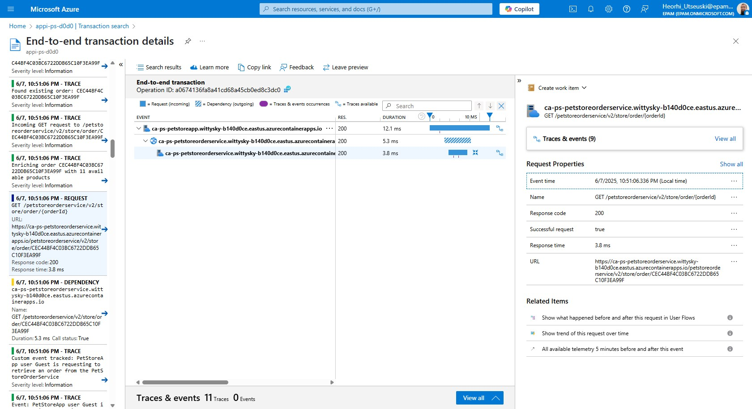

* Performance metrics relevant to the PetStore services.

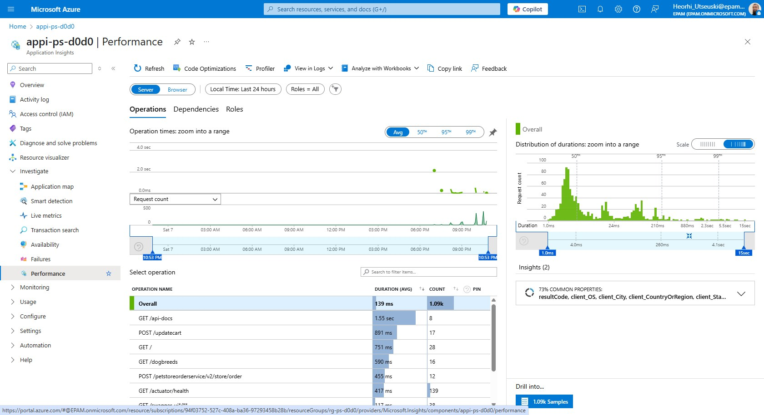

1. Implement Changes in the Code

* Screenshot of the added custom metric in PetStoreServiceImpl.getProducts()

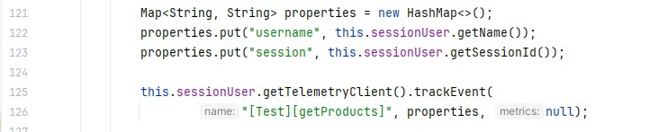

* Screenshot showing added logging for the number of returned items.



* Screenshots of the deployed PetStore services with implemented code changes.

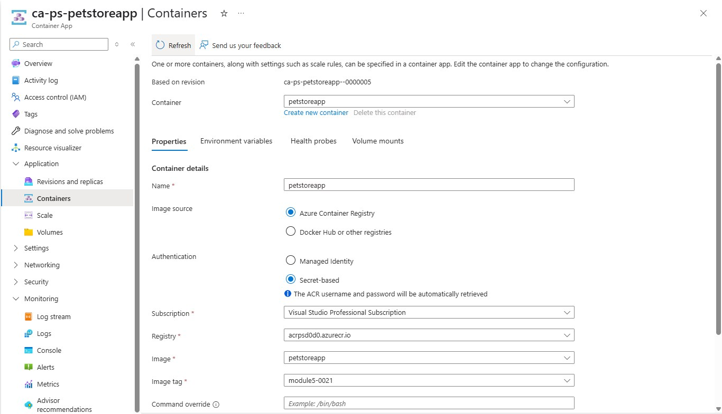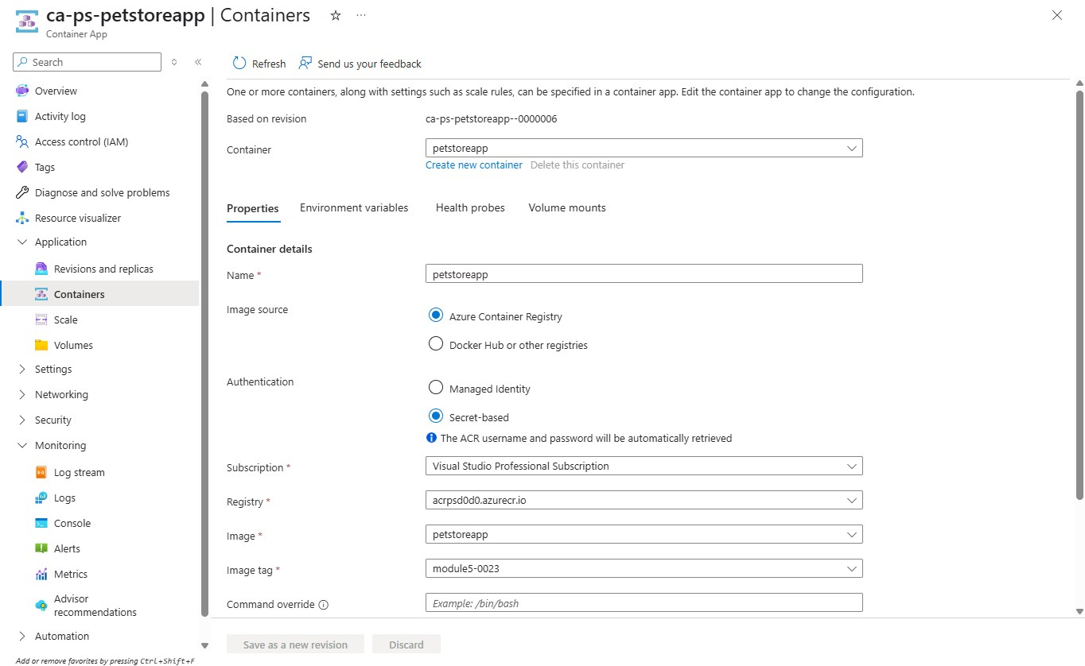

1. Examine Logs and Custom Events

* Screenshots of Application Insights displaying logged events and custom metrics.

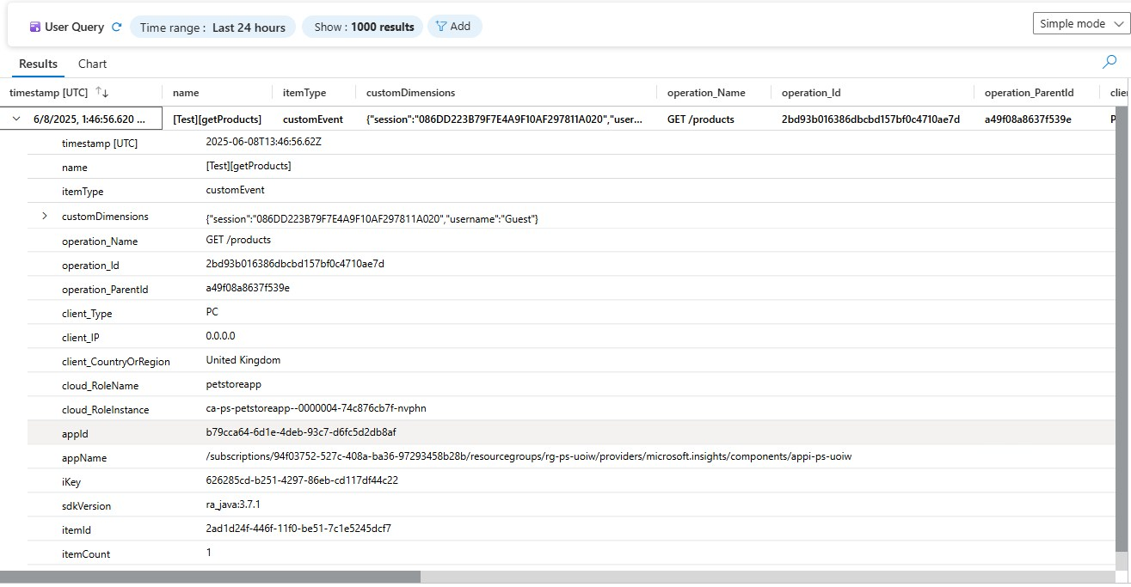

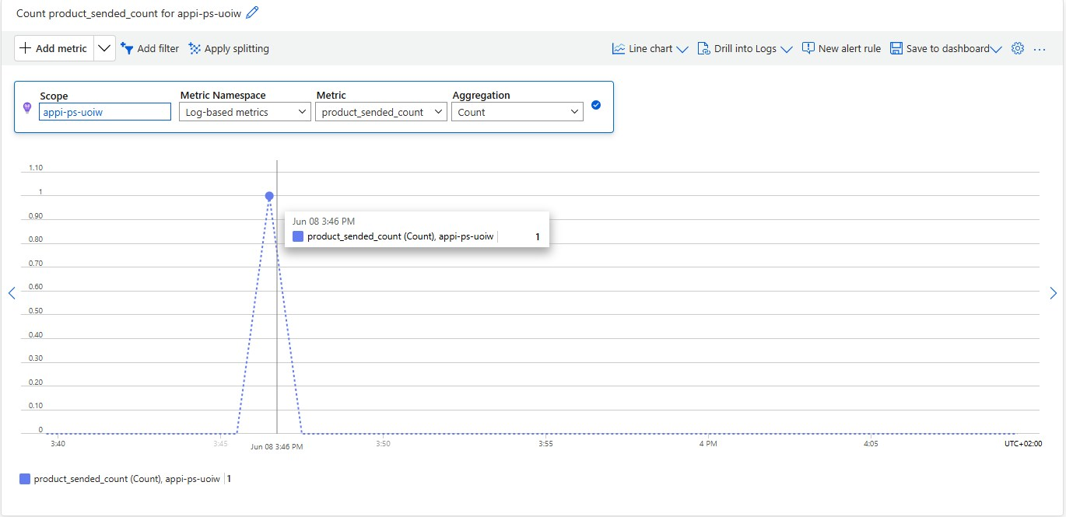

1. Use Kusto Query to Filter Logs

* Screenshot of a Kusto query filtering logs by the current session ID.

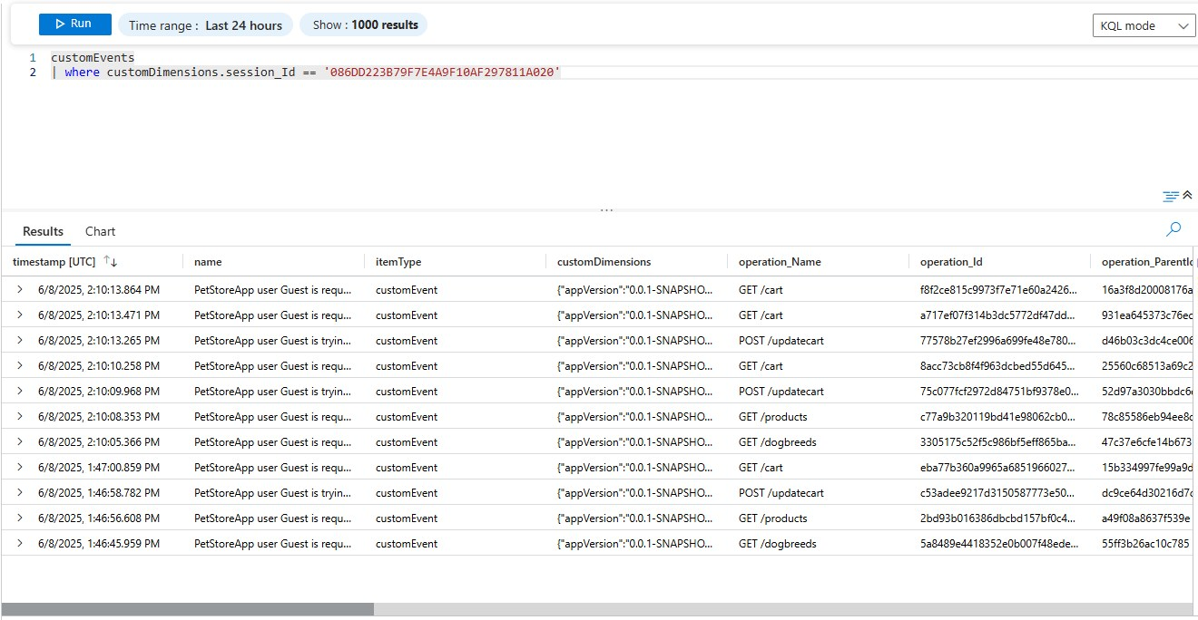

1. Introduce an Error in the Code

* Screenshot of the code with the introduced error line.

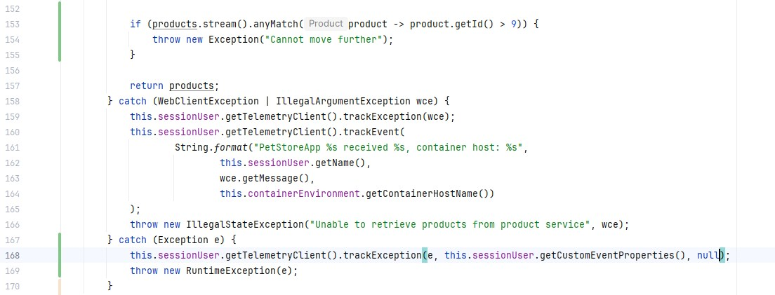

1. Redeploy Service and Check Logs

* Screenshots of the deployed PetStore services with the introduced error.

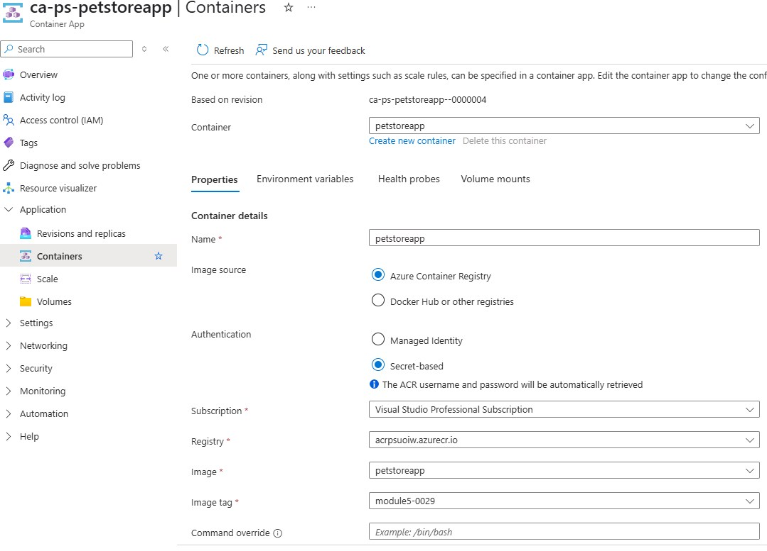

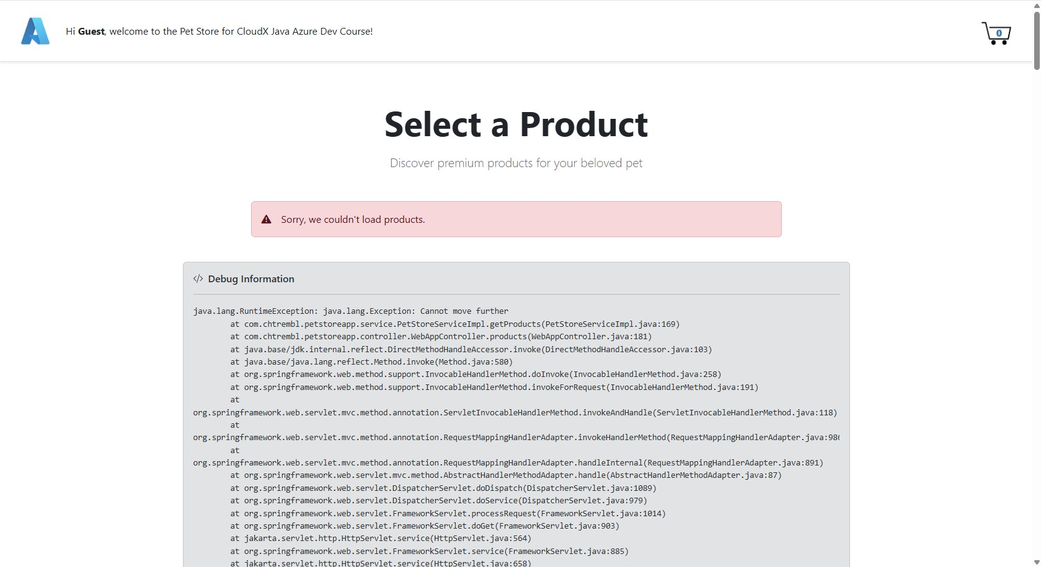

1. Use Kusto Query to Count Exceptions

* Screenshot of a Kusto query counting exceptions with specific error messages.

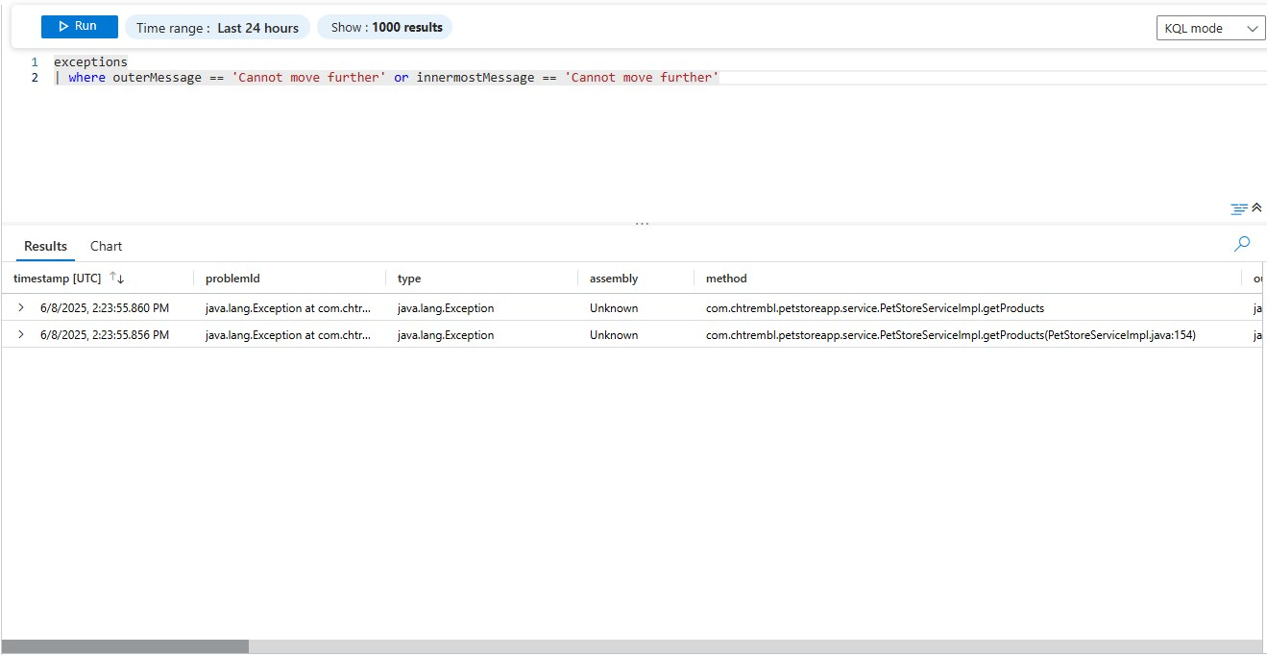

1. Examine Error in Detail

* Screenshot of the "Failures" tab in Application Insights displaying the stack trace of the error.

